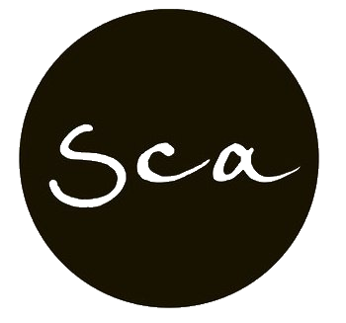

South Coast Academy
DATA CONTROL AND RECORD KEEPING POLICY (VET STUDENT LOANS)
1. Following records to be retained for at least 5 years:
➢ Records of all information given to each prospective student prior to enrolment, which includes:
➢ emails or other consultation records confirming provision of the payment options (upfront, VSL, VFH, other); accurate VSL information; location of the Schedules of Fees, Census Dates for approved courses, Policies and Procedures and Withdrawal form on the RTO website
- Course Information/Handout
- Pre-Training Review Outcome form
- Student Handbook (signed by each student on Orientation)
- Training Plan
- relevant Student Database (Wisenet/Moodle) entries.
➢ Records of enrolments:
- Enrolment Application Form and copy of the eCAF form provided by the student
- copy of VSL eligibility evidence
- copy of Loan Fee Notice for VSL Students
- copies of Commonwealth Assistance Notice (CAN)
- relevant Student Database (Wisenet) entries.
➢ Results of LL&N Assessments
➢ All correspondence between the provider and the student (or the student’s parent or guardian if under the age of 18) in relation to the course, including notices issued to the student
➢ Each use of student grievance procedure, including:
- formal grievance documentation (letters, complaint forms, emails etc.)
- Requests for Withdrawal (including special circumstance requests and supportive documentation)
- email confirmation of not incurring a debt following a withdrawal that occurred before/on
- census date
- email confirmation of incurring a debt following a withdrawal after census date (including
- information on special circumstance withdrawal and appeal process)
- Requests for Appeal (letters, forms, emails etc.)
- relevant Student Database (Wisenet) entries (informal grievances)
2. Following records must be retained for 7 years in accordance with the requirements of the Archives Act 1963:
➢ New Zealand SCV holders’ proof of eligibility to access VSL loan. Note: The following documents will be retained in the organisation’s Quality Management System (Archives) for a minimum of 5 years:
- Student Handbook that consists of relevant policies and procedures for students such as;
- Withdrawal policy
- VET Student Loans Information Booklet
- Schedule of fees that consist of census dates
- Course flyers

